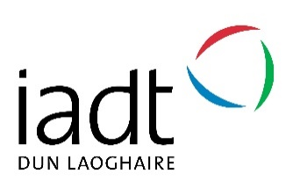

My Future IADT:

A pre-college access and transition initiative for post-primary students

A joint initiative between IADT and the Southside Partnership

Evaluation Report May 2017

Introduction 3
My Future IADT Model 4
International Best-Practice 4
Programme Aims 4
Programme Objectives 5
My Future IADT Structure 6
Programme Establishment (March 2016) 6
Re-Structure and Student Recruitment 6
Psycho-Educational Assessments 6
On-Campus Workshops 7
Teacher Training in Assistive Technology 8
Student Shadowing 9
Easter Camp 9
Evaluation 12
Future Developments 14
Continued Support for Programme Graduates 14
Structure 14
Psycho-Educational Assessments 14
Volunteer Input 14
Expansion 14
Student Profile 14
Strategic Value 15
Best Practice Example 15

Introduction
The transition from school to college can be stressful and uncertain for post-primary students and their families. In particular, young people who experience socio-economic disadvantage benefit from high quality support at this time, and of this group, those with special educational needs are the most in need of support. Whilst there are robust international models targeting planned transitions to college for students with disabilities, the concept is in its infancy in Ireland. Experiencing a taste of college means that students:
- are prepared for new teaching and learning experiences, and physical environments,
- have opportunities to meet and engage with other young people who deal with the same or similar challenges,
- are provided with firsthand knowledge that facilitates good future choices.
The Institute of Art, Design and Technology (IADT) offers undergraduate and postgraduate degrees that provide students with the creative and practical skills to thrive in Ireland’s growing creative industries. The Dun Laoghaire campus is home to the National Film School, extensive studio spaces, and the Media Cube – a space for start-up tech and creative media companies. IADT has an established outreach service targeting Access to IADT for students with disabilities, students from socio-economically disadvantaged backgrounds and mature students. Currently, IADT has the highest proportion of the student body registered with disabilities of all HEIs nationally, and Access initiatives include a focus on those students experiencing both socio economic disadvantage and disability.
In the academic year 2016 - 2017, IADT piloted a unique transition programme, My Future IADT, for students who experience socio-economic disadvantage and also present with disabilities. The project was financed through the Dormant Account Fund and run in conjunction with the Southside Partnership and four local schools. This report sets out the development, implementation and outcomes of the My Future IADT project.

My Future IADT Model

International Best-Practice
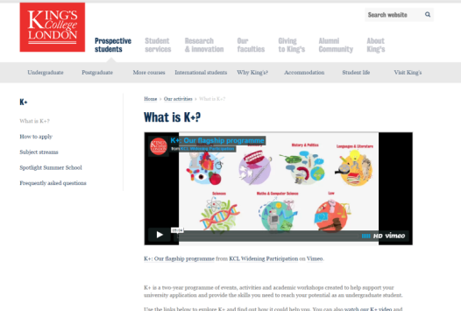

My Future IADT was modelled on established best-practice third level access schemes already in use at King’s College London, University College Dublin and Dublin City University. Within this framework, My Future IADT is unique and innovative in the focus it places on students with a disability and its use of specialist support from within IADT’s student support team for these second level students. Furthermore, it provides a holistic approach to access that works with teachers, parents, community leaders (Southside Partnership) to strengthen the chances of a successful transition to third level for participants on the programme. Finally, it is founded on the strong educational psychology principles of positive psychology and motivational interviewing to provide academic rigour behind the intervention.

Programme Aims
The aims of the programme were as follows:
- Encourage students to complete second level education.
- Encourage access to third level.
- Promote third level to the wider community (parents, teachers, students).
- Strengthen relationships between community groups (Southside Partnership), local DEIS schools and IADT.

Programme Objectives
The objectives of the programme were as follows:
- Students set career goals to help increase motivation for leaving cert study.
- Students understand how to navigate the CAO system, DARE/HEAR additional access schemes and SUSI grant system.
- Students develop study skills to prepare for the challenge of the leaving certificate.
- Students begin using state of the art digital technology to assist in study and prepare for digital learning at third level.
- Students develop emotional resilience through a focus on wellbeing.
- Students become familiar with the IADT campus.
- Students shadow current IADT students to get a taste of college life.
- Teachers are trained in the use of Assistive Technology for learning.

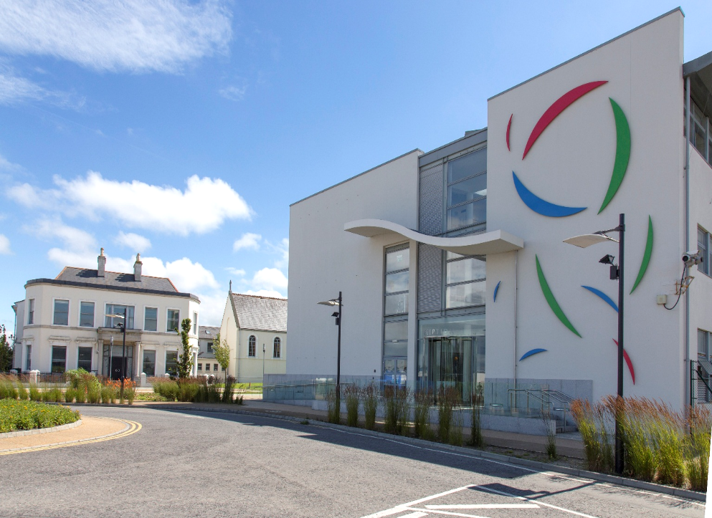
Image 1: IADT Campus

My Future IADT Structure

Programme Establishment (March 2016)
IADT and Southside Partnership, the programme’s coordinators, made contact with four local schools with DEIS status or a significant proportion of students from socio-economically disadvantaged backgrounds and invited them onto the programme:
- Rockford Manor
- Cabinteely Community School
- Holy Child Community School
- St Laurence’s College
A steering group was formed and the project structure and timeline put in place.

Re-Structure and Student Recruitment
The programme had originally been envisaged as psycho-educational assessments followed by on-campus workshops over 22 Saturdays. However, the steering group did not think this was viable with teachers expressing concerns that students would never make it to 22 weekends in the year. Therefore the programme was re-structured into 5 core activities:
- Provision of Psycho-Educational Assessments
- On-Campus Workshops on Wednesday Half-Days
- Teacher Training in Assistive Technology
- Student Shadowing
- Easter Camp.
Liaison teachers in each school recruited a minimum of 8 students for the programme. Students were senior cycle and the majority were identified as requiring a psycho-educational assessment. A total of 39 students participated in the programme.

Psycho-Educational Assessments
25 students on the programme availed of psycho-educational assessment. 60% received a diagnosis through the assessment process (Table 2 below).
Diagnosis | Number / 25 | %
Dyslexia | 12 | 48
Dyscalculia | 1 | 4
ADHD | 1 | 4
No diagnosis | 10 | 40
Table 1: Results of Psycho-Educational Assessments

On-Campus Workshops
Twenty-nine students attended a series of on-campus workshops in 2 separate groups (see Table 1 below). The workshops covered the use of literacy software (Texthelp Read and Write Gold and Grammarly), using Gmail cloud computing, using voice activated and text to speech freeware, and an introduction to Adobe Creative Cloud. Study skills sessions focused on organisation and time management, memory, and reading / writing skills. Mindfulness sessions focused on relaxation techniques for leaving cert study.
Workshops | Details | Group 1 Date | Group 2 Date
Study Skills 1 | Students began to receive study skills for leaving cert advice from a staff expert at IADT., with an initial focus on study planning. | October 2016 | January 2017
Assistive Technology 1 | Students learned how to use specialist disability software for learning such as screen reading, spelling and grammar and voice recognition software. | October 2016 | January 2017
Study Skills 2 | Students continued to develop their study skills with a focus on reading and note taking. | November 2016 | February 2017
Assistive Technology 2 | Students learnt more about cloud computing and free apps and extensions they could use themselves at home to aid their learning. | November 2016 | February 2017
Study Skills 3 | Students completed their study skills training with a final focus on memorisation and exam techniques. | December 2016 | March 2017
Wellbeing | Students practiced mindfulness meditation techniques for well-being with an IADT assistant psychologist. | December 2016 | March 2017
Table 2: On-Campus Workshop Content
Three additional students with complex disabilities (sensory and physical) attended a separate one-day campus tour and overview of course choices at IADT.

Teacher Training in Assistive Technology
Twelve laptops were purchased by the programme and loaned to three schools for use by students completing the My Future IADT programme. These were loaded with specialised software: Texthelp Read and Write Gold, Microsoft Office, and Adobe Creative Cloud. In February 2017, teachers from each of the linked schools were provided with training in the use of specialist software for students with disabilities, together with strategies for using these resources in the classroom. Staff from all of the schools provided positive feedback on both the student and teacher workshops:
“This is an excellent program opening post-primary schools up to the possibilities and opportunities that technology can offer us for the future. The program will be especially beneficial for our students who require learning support and come from international backgrounds, and require language support across all subjects. Having come from an industry background+ prior to education I believe this better prepares students for future working life and the skills they need for living and employment.” (Rockford Manor).
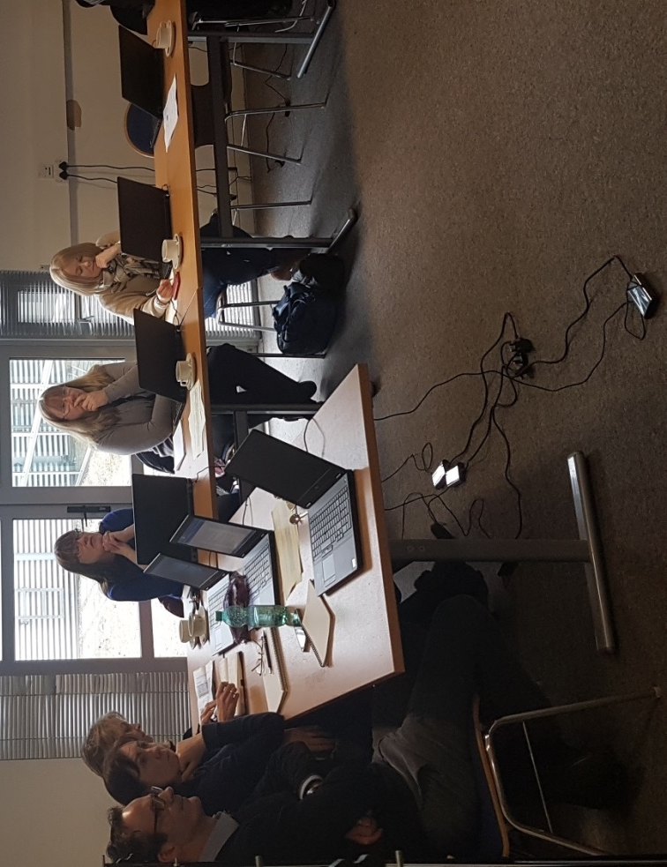
Image 2: Teachers Undertaking Assistive Technology Training

Student Shadowing
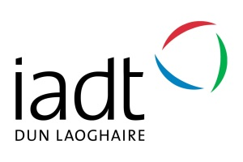
In March 2017, nineteen students from both Groups 1 and 2 spent a full day shadowing IADT students selected from eleven courses (Table 3). There are several advantages to engaging in a college shadowing opportunity. Firstly, students gain a sense of the flow of college life in which students move from class to class, but with varied periods of unstructured time in between learning activities. Secondly, students have an opportunity to sit in on lectures or practical sessions within their intended field of study or area of interest, resulting in a better sense of course suitability or relevance. Finally, students can familiarize themselves with the campus, permitting them to gain a sense of the layout and general ambience, helping them to make informed decisions about whether the course, institution and campus are a good fit with their own personal preferences.
Course | No. of Students
Art | 2
Entrepreneurship and Management | 2
Animation | 3
Applied Entrepreneurship | 2
Arts Management | 2
Creative Computing | 2
English, Media, and Cultural Studies | 1
Creative Media Technologies | 2
Applied Entrepreneurship | 1
Photography | 1
3D Design, Modelmaking and Digital Art | 1
Table 3: Student Shadowing Days

Easter Camp
Seventeen students attended four days of a non-residential Easter Camp. The majority of students had an identified learning need, and had previously attended either Phase 1 (September to December 2016) or Phase 2 (January to April 2017) sessions. Two 6th year students on the programme elected not to participate in the Easter Camp as they had already identified IADT as their first-choice destination, choosing instead to focus on concentrated Leaving Certificate study.
The Easter Camp was designed as an immersive experience in which students engaged in activities that captured real college experiences. It took place across the entire IADT campus, utilizing teaching spaces, radio and photography studio spaces and computer labs. Specialist input was provided by IADT staff as well as Naidu+, a life coaching company who provide pro-bono work for IADT’s Access Service. The full schedule is indicated in Table 5 below.
Time | Mon 10th April | Tues 11th April | Wed 12th April | Thurs 13th April
10-11 | Welcome  Ice-breakers.  Explain project for the week | Choosing your future career | 10.00-10.30 What goes in a portfolio | 10-10.45 Accessing College  SUSI Grants  Access Routes to College  Intro to ladder of qualifications.
Studio photography workshop
Students introduced to the Photo Studio and make a portrait or still life image based on what motivates them.
11-12 | Life coaching  Motivation / goal setting session | Problem Based Learning  “Junk Food Should Be Banned” school café tender presentation |  | 10.45-11.30 Mindfulness meditation
11.30 – 12 Presentation of Motivation Posters
Students present their work
12-12.30 | LUNCH IN CANTEEN
12.30-13.15 | Pixar in a Box Animation class  12.30-13.00 Visit animation studio  13.00-14.00 Animation lab session C012 | Campus Tour | 12.45 Reachout Introduction to mental health resources | My Future IADT filming  Students create a video of their learning on the project.
13.15-14.00 |  | Photography tutorial – what motivates me? | Graphic design workshop  Students shown how to edit photographs and design their own motivational poster.
Table 4: Easter Camp Timetable
Students were provided with an individual workbook which outlined the daily schedule, venue, staff associated with activities, and homework tasks associated with the following day’s activities. A feedback template was provided in the back of the workbook. On a scale of increasing enjoyment / usefulness (1 to 10), the overall camp experience was rated at 9, activities rated as 9, and guest speakers rated as 8.75. Students also provided strong individual feedback:
- “I feel super productive and motivated”
- “I thought it was a great experience and I got a chance to meet new people.”
- “I also thought it was good to look at sectors I wouldn’t consider doing.”
- “Today I got to present my poster which I was scared for, but I got over my fear.”
- “I think that overall the week was worthwhile and I’d definitely do a similar course again.”

Image 3: A Student’s Motivational Poster

Evaluation
A total of 39 students participated in and benefited from the My Future IADT pilot which took place across from March 2016 – May 2017 (Table 4). It is clear from participation rates and feedback that this was a valuable initiative which could be further expanded and developed as a permanent pre-entry and outreach strategy, delivered in partial fulfillment of the IADT Strategic Plan.
School | Total no. of students
Cabinteely CS | 11
Holy Child Secondary | 6
Rockford Manor | 15
St Laurence College | 7
Table5: School Participation Rates
The programme worked successfully in liaison with Southside Partnership and local schools to identify students, address their challenges, and harness the power of Assistive Technology. It equipped students with the skills to enhance their Leaving Certificate study, and broadened their choice of post-school opportunities. Teachers noted increased levels of confidence and emerging aspirations for a future third level career, demonstrating that exposure to opportunities for personal development is crucial for students whose families may not have completed the senior cycle education.
“Our students have benefitted greatly from supports in the areas of SLDs. They have been given the tools and confidence to work towards 3rd level education, when they previously may have felt that this was not an option. Our staff have also received invaluable support in the area of assistive technology, better equipping us to help all our students going forward. We as a school look forward to furthering this relationship in the future.” (Cabinteely Community School)

The Easter Camp that culminated the initiative was a transformative experience for many of the young people who attended. Students on the camp left with a coherent education and career plan having selected their Higher Education CAO choices as well as investigated back-up options and Further Education routes to help them reach their career goals.

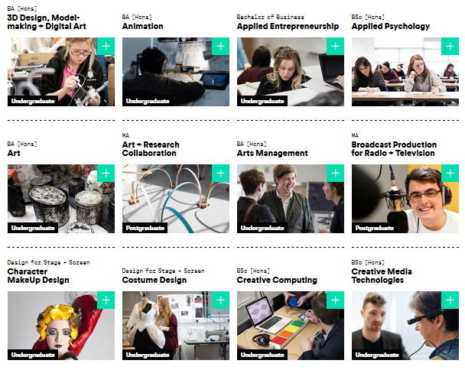
Image 4: IADT Undergraduate Courses

Future Developments

Continued Support for Programme Graduates
My Future IADT should continue to offer support to the students who completed the 2016 – 2017 programme. It is suggested that this cohort be invited into IADT during the Autumn Term 2017 for one-to-one meetings covering motivational interviewing, guidance in applying to the DARE / HEAR schemes, and advice on portfolio work. In January / February 2018 a refresher workshop would be invaluable in maintaining motivation and finalizing plans. These students might also participate in the first day of the 2018 Easter Camp, acting as motivational role models or ambassadors.

Structure
The timeframe of My Future IADT should be re-structured into two phases: on-campus workshops for different groups as Phase 1, with shadowing days and an Easter Camp as Phase 2.

Psycho-Educational Assessments
The provision of psycho-educational assessments is the most costly aspect of the programme. It is debatable whether much value is received from this expensive and time-consuming process. A recent shift to allocation of resources at Second Level based on school-based assessment and towards Universal Design for Learning at Third Level means that undertaking a full assessment may no longer be necessary to access support.

Volunteer Input
It is suggested that Student Ambassadors from IADT are involved throughout the programme; inspirational talks from third level students and recent graduates can provide a powerful message about diversity, aspiration, and maximizing opportunities to achieve potential.

Expansion
My Future IADT should expand provision of the programme to three further DEIS schools in the local area over the next 12 months: St Killian’s Community School, St Tiernan’s Community School, and Ballinteer Community School.

Student Profile
The student profile for participants in My Future IADT should reflect a balance of students in schools; a mix of students with high academic potential, students from very disadvantaged backgrounds and students with disabilities. An important part of the recruitment process should be working in tandem with link teachers, to ensure that students make a long-term commitment to all aspects the programme, to reduce risk of drop-out.

Strategic Value
The IADT Strategic Plan 2014 – 2018 sets out several priorities that are directly related to the student cohorts targeted by My Future IADT. The intent of Strategic Priority 3 is to: “widen access, opportunity and support for students from disadvantaged backgrounds… and those with learning difficulties and disabilities”. My Future IADT clearly addresses this strategic priority and establishes IADT at the forefront of innovative transition practices.

Best Practice Example
The vision and structure of the My Future IADT project is an example of best practice in establishing links between Higher Education institutions and under-represented student cohorts. To that end, funding streams for the continuation of this programme should be investigated as a priority. Furthermore, this model can be shared with other Higher Education Institutes to encourage good practice in the field.
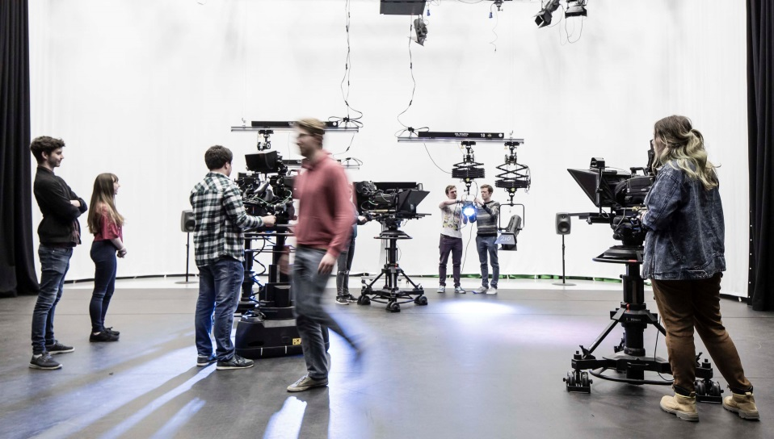
Image 5: IADT Students at College

Dun Laoghaire Institute of Art Design and Technology (2014). Strategic plan 2014-2018 [Online]. Available from: https://issuu.com/dliadt/docs/iadt_strategic_plan_2014-2018 [Accessed 10 October 2016].

