Add-on Degree & Internal Transfer Application Form
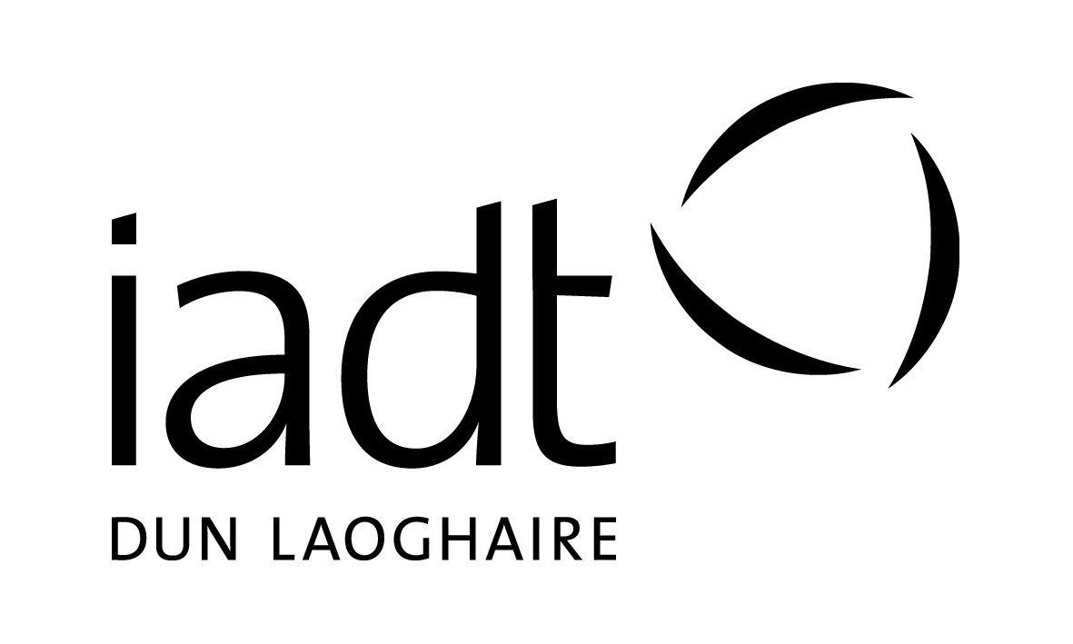
Office use
For use by current IADT students only

Please complete all sections of this form in BLOCK CAPITALS using BLACK ink.
Completed forms must be returned to the admissions office before:
4 p.m. Friday the 29th of March 2019

Section 1: Personal Details

Surname: _________________ First Name(s):_________________ Date of Birth: ____________________

Address:_________________________________________________ PPS Number: ____________________

__________________________________________________________ Gender (circle): M F

__________________________________________________________ Country of Birth: ________________

Email: ____________________________________________________ Nationality: _____________________

Mobile: ___________________________________________________ Phone: _________________________

Section 2: Programme Applied For

Programme Code: _________________________ Preferred year of entry (circle): 2nd 3rd 4th

Programme Title: ________________________________________________________________________

Section 3: Current IADT Programme & Student Number

State Programme Code and year (e.g. 1st, 2nd, etc.): DL_______ Year: _______

Current Student Number: ____________________

Section 4: Declaration

I certify that the information provided in this application is accurate and correct.

Signature of the Applicant: _____________________________ Date: _______________________

Note: The Institute may use information provided by the applicant to create an initial student record and compile statistical information for use by the Institute or appropriate external bodies. No statistical data which can identify individuals will be published.

Completed Application Forms and References should be mailed to:

Admissions Office (Internal Transfer Application),
Institute of Art, Design and Technology
Kill Avenue, Dun Laoghaire,
Co. Dublin.

Or emailed to: admissions@iadt.ie

No later than 4 p.m. Friday the 29th of March 2019

This form is only for use by currently registered students at IADT who wish to:

- Apply for an add-on level 8 degree upon completion of their current level 7 programme.
- Apply for a transfer from their current programme to year 2, 3 or 4 of an alternative programme at IADT.

If you are not currently a registered student at IADT and wish to apply for one of our Add-on Degrees or for advanced entry to year 2/3/4 of any of our programmes you must apply through www.cao.ie

1. Add-on Degree Programmes:

Applicants seeking admission to any of the add-on programmes listed below must be currently registered in the corresponding level 7 award (DL701 or DL704).

Code | Programme Title | Department
DL801 | Bachelor of Business (Hons) in Entrepreneurship | Entrepreneurship
DL804 | BA (Hons) in Creative Music Production | Film + Media

2. Internal transfer into Year 2, 3 or 4 of a programme:

Occasionally places become available in the 2nd, 3rd or 4th year of our programmes. These places are normally very limited so it is advisable for students to also apply to the CAO for the 1st year of their chosen programme. See www.cao.ie for application information & deadlines.

If you are currently registered as a student on an undergraduate programme at IADT and wish to be considered for a transfer to an alternative programme then complete this form. It is advisable to discuss your application with the programme team also.

What happens now? - Your application will be assessed and the course staff will be in touch with you regarding your application.

You should forward this completed application form to:

Admissions Office (Internal Transfer Application),
Institute of Art, Design and Technology
Kill Avenue, Dun Laoghaire,
Co. Dublin.

Or by email to: admissions@iadt.ie

Closing date for receipt of completed application forms is

4.00 pm on the 29th of March, 2019

You are advised to keep a copy of this application for your own records.

