Postgraduate Application Form
Office use
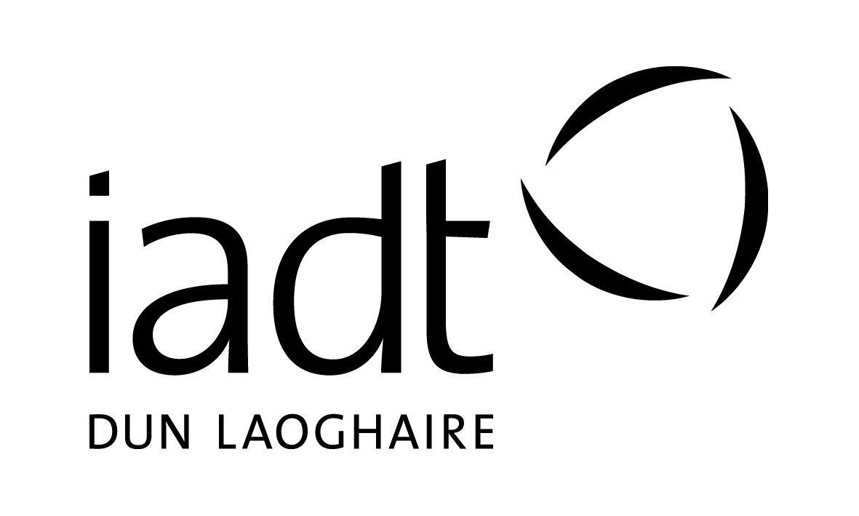
Applicants seeking admission to taught postgraduate courses

Please complete all sections of this form in BLOCK CAPITALS using BLACK ink.
If you are applying for more than one course, please complete a separate form for each one.

Completed forms must be returned to the postgraduate admissions office before:
4 p.m. Friday 4th May 2018

Section 1: Personal Details

Surname: _________________ First Name(s):_________________ Date of Birth: ____________________

Address:_________________________________________________ PPS Number: ____________________

__________________________________________________________ Gender (circle): M F

__________________________________________________________ Country of Birth: ________________

Email: ____________________________________________________ Nationality: _____________________
Is your email address easy to read? – it should be clear & legible
Mobile: _________________________
On-Line Projects Link: _______________________________________
(if applicable)

Section 2: Course Applied For refer to Postgraduate Course Codes for codes

Course Code: _________________________

Course Title: ________________________________________________________________________

Section 3: Are you currently a registered student at IADT?

Yes If Yes, state Course Code and year: DL________ Year: _______
No Current Student Number: ____________________

Section 4: Education

Please indicate the level of your current highest educational achievement:

Level 5 (Leaving Cert / FETAC)
Level 6 (Higher Cert / FETAC)
Level 7 (Ordinary Degree)
Level 8 (Hons Degree)
Level 9 (Masters)
Level 10 (Doctorate)

Name of College/Institution: ____________________________

Course Title: _________________________________________

Year of completion / anticipated date of completion: ________

Copy of Cert / Transcript included: Yes No

Section 5: Recognition of Prior Learning (RPL)

IADT welcomes applications from those whose academic background is non-traditional but who have proven relevant experience.

If you do not meet the standard educational requirements for the course and wish to be considered as an RPL candidate, please tick this box:

We will make contact with you.

For further information on the RPL process see: RPL Process Details
Section 6: Language Competence

First language*: _________________________________

Second language: _______________________________
Speak Read Write
* If your 1st language is not English you must include evidence of English language qualifications, such as IETLS or TOEFL. Please see English Language for acceptable qualifications.

Section 7: Health, Disability, Specific Learning Difficulty

If you consider yourself to have a disability, significant health problem and/or specific learning difficulty please tick this box:

Please attach medical documentation (where available/relevant) or additional information on a separate sheet.

We request this information to enable us to accommodate your needs, where reasonable.
All information provided will be treated with sensitivity and in as confidential a manner as possible.

Section 8: References

You must provide one written academic reference and one written employment reference (if relevant).
These should be emailed to postgradadmissions@iadt.ie

We will assume permission to contact the named referee(s) unless you tell us otherwise.

Education Reference

Name of Referee: ______________________________ Telephone No. ___________________

E-mail address ________________________________________________________________________

Employment Reference (if relevant)

Name of Referee: _______________________________ Telephone No. ____________________

E-mail address ________________________________________________________________________

E-mail address _________________________________________________________________________

Section 9: Declaration

I certify that the information provided in this application is accurate and correct.

Signature of the Applicant: _____________________________ Date: _______________________

Note: The Institute may use information provided by the applicant to create an initial student record and compile statistical information for use by the Institute or appropriate external bodies. No statistical data which can identify individuals will be published.

Completed Application Forms and References can be emailed or posted to:

Postgraduate Admissions Office
Institute of Art, Design and Technology
Kill Avenue, Dun Laoghaire,
Co. Dublin
postgradadmissions@iadt.ie

Please note that programmes are subject to a minimum number of approved applicants to proceed.

INCOMPLETE APPLICATION FORMS WILL NOT BE PROCESSED
DL901 | MA Screenwriting
DL902 | MA Broadcast Production
DL904 | MSc Cyberpsychology
DL906 | PGDip Business Cultural Event Management
DL907 | MA Art & Research Collaboration
DL908 | MSc User Experience Design
DL909 | MA Digital Entrepreneurship
DL910 | PGCert Digital Start-up
DL912 | MA Creative Production & Screen Finance
DL913 | PGDip User Experience Design
DL914 | MA Interdisciplinary Design Strategies

final reminder checklist

Before forwarding your application to the Institute, please ensure that you have included the following:

- Copy of Transcripts of Results (where applicable)

- Curriculum Vitae (CV)

- Proof of Identity – Passport / Driver’s License (original should not be forwarded).

- Copy of Certificate of English Language Competence (where applicable).

- Separate sheets if used, in response to sections 7, 8 and 9.

- References – attach 2 written references from your stated referees or have them emailed to postgradamissions@iadt.ie

- If you are applying for admission to more than one programme please complete separate application forms for each programme.

- If you are applying to the MA in Art and Research Collaboration you must include a Project Proposal, including the following: Description of the concerns/ideas/materials/techniques you intend to explore in your project (approx 500 words). An indication of the project format (artworks/curatorial project/text-based). References to research by others, either within and/or beyond the art field, relevant to your project (max 500 words). If your project involves the making of artworks, you must also submit images of your previous work (5-10 artworks). Please caption all images with title, date and medium. You can also include links to documentation of video/audio/performance work on your website/vimeo/soundcloud/tumblr. If you wish to develop a specifically text-based project, please include a sample of your previous writing (max 3000 words).

- Please make sure you have consulted the relevant course page http://www.iadt.ie/courses for any additional course specific application requirements.

Please note that programmes are subject to a minimum number of successful applicants to proceed.

Closing date is:

4.00 pm, Friday 4th May, 2018

The Institute reserves the right to cancel, suspend or modify its programmes at any time.
The Institute reserves the right to amend the list of elective subjects being offered on any programme.

