Postgraduate Application Form
Office use
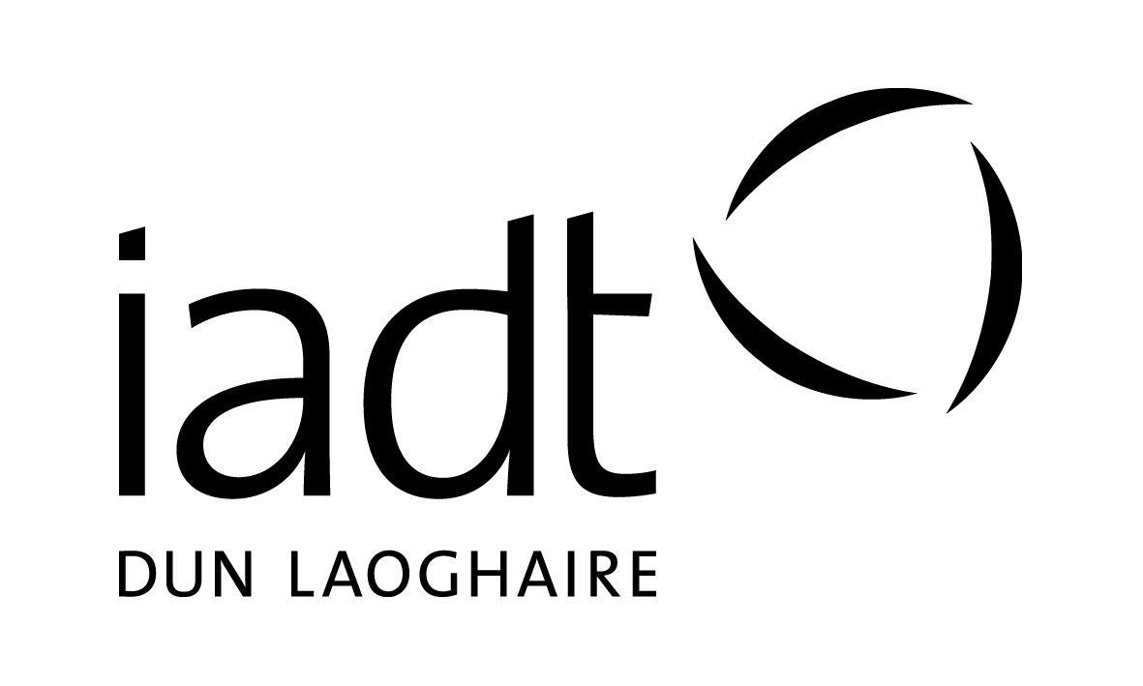
Applicants seeking admission to taught postgraduate programmes at IADT

Please complete all sections of this form in BLOCK CAPITALS using BLACK ink.
If you are applying for more than one programme please complete a separate form for each programme.

Completed forms must be returned to the admissions office before:
4 p.m. Friday the 5th of May 2017

Section 1: Personal Details

Surname: _________________ First Name(s):_________________ Date of Birth: ____________________

Address:_________________________________________________ PPS Number: ____________________

__________________________________________________________ Gender (circle): M F

__________________________________________________________ Country of Birth: ________________

Email: ____________________________________________________ Nationality: _____________________

Mobile: ___________________________________________________ Phone: _________________________

Section 2: Programme Applied For (see notes for relevant codes/titles)

Programme Code: _________________________

Programme Title: ________________________________________________________________________

Section 3: Are you currently a registered student at IADT?

Yes If Yes, state Programme Code and year: DL________ Year: _______
No Current Student Number: ____________________

Section 4: Education

Please indicate the level of your highest educational achievement: (you must attach evidence)

Level 5 (Leaving Cert / FETAC)
Level 6 (Higher Cert / FETAC)
Level 7 (Ordinary Degree)
Level 8 (Hons Degree)
Level 9 (Masters)
Level 10 (Doctorate)

Name of College/Institution: ____________________________

Course Title: _________________________________________

Year of completion / anticipated date of completion: ________

Copy of Cert / Transcript included: Yes No

Section 5: Recognition of Prior Learning (RPL)

Applications are accepted from individuals who have proven relevant experience and whose academic background is non-traditional.

If you do not meet the standard educational requirements for the course and wish to be considered as an RPL candidate please tick this box:

You will be contacted by the programme representative responsible for RPL applicants.

For further information on the RPL process please see
http://www.iadt.ie/study/how-to-apply/recognition-of-prior-learning
Section 6: Language Competence

First language*: _________________________________

Second language: _______________________________
Speak Read Write
* If your 1st language is not English you must include separate evidence of English language qualifications, such as IETLS or TOEFL Certificates. Please refer to our current Prospectus.

Section 7: Health, Disability, Specific Learning Difficulty

If you consider yourself to have a disability, significant health problem and/or specific learning difficulty please tick this box:

Please attach medical documentation (where available/relevant) or additional information on a separate sheet.

Provision of the information in this section is requested to enable the Institute of Art, Design and Technology to accommodate, where reasonable, your needs. All information provided will be treated with sensitivity and in as confidential a manner as possible.

Section 8: References

You must provide two written references; one academic and one employment reference (where applicable). These can be emailed to admissions@iadt.ie or posted to: Admissions Office, IADT, Kill Avenue, Dun Laoghaire, Co Dublin. Please fill in the name and contact details of your referees.

We will assume permission to contact the named referee(s) unless you tell us otherwise.

Education Reference

Name of Referee: ______________________________ Telephone No. ___________________

E-mail address ________________________________________________________________________

Employment Reference (if relevant)

Name of Referee: _______________________________ Telephone No. ____________________

E-mail address _________________________________________________________________________

Section 9: Declaration

Where did you first hear about this course: ______________________________________

I certify that the information provided in this application is accurate and correct.

Signature of the Applicant: _____________________________ Date: _______________________

Note: The Institute may use information provided by the applicant to create an initial student record and compile statistical information for use by the Institute or appropriate external bodies. No statistical data which can identify individuals will be published.

Completed Application Forms and References should be mailed to:

Admissions Office (Postgraduate Application),
Institute of Art, Design and Technology
Kill Avenue, Dun Laoghaire,
Co. Dublin.

No later than 4 p.m. Friday the 5th of May 2017

Please Note: This application form should be completed with reference to the ‘notes’ attachment.

Please complete the Postgraduate application form if you are applying for any of the programmes listed below.

Programme Code | Programme Title
DL906 | Postgraduate Diploma in Business in Cultural Event Management
DL909 | Master of Business in Digital Entrepreneurship
DL910 | Postgraduate Diploma in Digital Start-Up
DL905 | MA in Public Culture Studies
DL904 | MSc in Cyberpsychology
DL908 | MSc in User Experience Design
DL901 | MA in Screenwriting
DL902 | MA in Broadcast Production
DL907 | MA in Art & Research Collaboration

What happens now?

Your application will be assessed and:

1. Email acknowledgement of your application will be sent.

2. Ineligible candidates will be informed by email.

3. Eligible candidates may be invited for interview and/or portfolio assessment.
Certain courses do not invite for interview but offer based on application information.

4. RPL candidates will be contacted and guided through the RPL procedures

5. All eligible candidates informed of outcome of application process
At this stage you may receive:
- A definite offer
- A conditional offer pending examination/assessment results
- You may be put on a waiting list (pending confirmation of availability of places)
- An unsuccessful letter

final reminder checklist

Before forwarding your application to the Institute, please ensure that you have included the following:

- Copy of Transcripts of Results (where applicable)

- Curriculum Vitae (CV)

- Proof of Identity – Passport / drivers license (original should not be forwarded).

- Copy of Certificate of English Language Competence (where applicable).

- Separate sheets if used, in response to sections 7, 8 and 9.

- References – attach 2 written references from your stated referees or have them emailed to admissions@iadt.ie

- If you are applying for admission to more than one programme please complete separate application forms for each programme.

- If you are applying to the MA Art Research Collaboration you must include a Project Proposal consisting of 4 x A4 pages comprising plans and images of a proposed project of practice-based work and explanatory text, if the research is envisaged as being delivered primarily through practice-led enquiry. If the project involves the production of artworks, applicants must also submit documentation of previous artwork (max. 10 images on USB flash drive/memory stick). If the practice involves the production of written texts, applicants must also submit samples of previous writing, and those working with video/audio should submit vimeo or soundcloud links. If the project research is envisaged as being delivered primarily through textual enquiry a written proposal should be submitted (approx 3000 words).

- Email address: Is your email address easy to read? - Please ensure that it is clear and legible.

Please note that programmes are subject to a minimum number of approved applicants to proceed.

You should forward this completed application form to:

Admissions Office (Postgraduate Application),
Institute of Art, Design and Technology
Kill Avenue, Dun Laoghaire,
Co. Dublin.

Or by email to: admissions@iadt.ie

Closing date for receipt of completed application forms is:

4.00 pm, 5th May, 2017

You are advised to keep a copy of this application for your own records.

INCOMPLETE APPLICATION FORMS WILL NOT BE PROCESSED

The Institute reserves the right to cancel, suspend or modify its programmes at any time. The Institute reserves the right to amend the list of elective subjects being offered on any programme.

