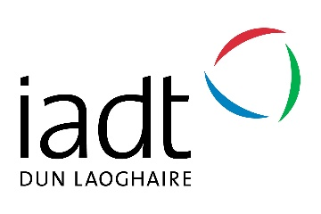

Booking Form
Part time Courses | Summer 2017

Please return by post to:
Part Time Courses, IADT, Kill Avenue, Dun Laoghaire, Co. Dublin with your payment
Email to barbara.carraher@iadt.ie or Phone (01) 239 4631 for credit card bookings.

------------------------------------------------------------------------------------------------------------------------------------------------------

Your Details (Please print in block capitals)
Name:
Address:

Course title:
Start date of course: Fee:

Telephone (Day-time): Telephone (Evening):
Mobile:
Email address: I am over 16 years of age:

Payment Method (please tick one):
Credit card Cheque
Laser Other

Card type (please tick one):
Mastercard Visa Other

Card no: __ __ __ __ __ __ __ __ __ __ __ __ __ __ __ __

Expiry date: __ __ / __ __ / __ __ Security Code: __ __ __

I have read and accepted the conditions:

Card Holders Details
Signature: Name (block capitals):
Date: Address:

Student Parking Permits:
If you require a student parking permit while attending your course please advise us of your Car Registration Number: __________________.

Pay and Display is in operation for IADT parking spaces and you should familiarise yourself with the current parking regulations on the IADT website. Your permit will be issued on the first morning of your course.

