Certificate Course
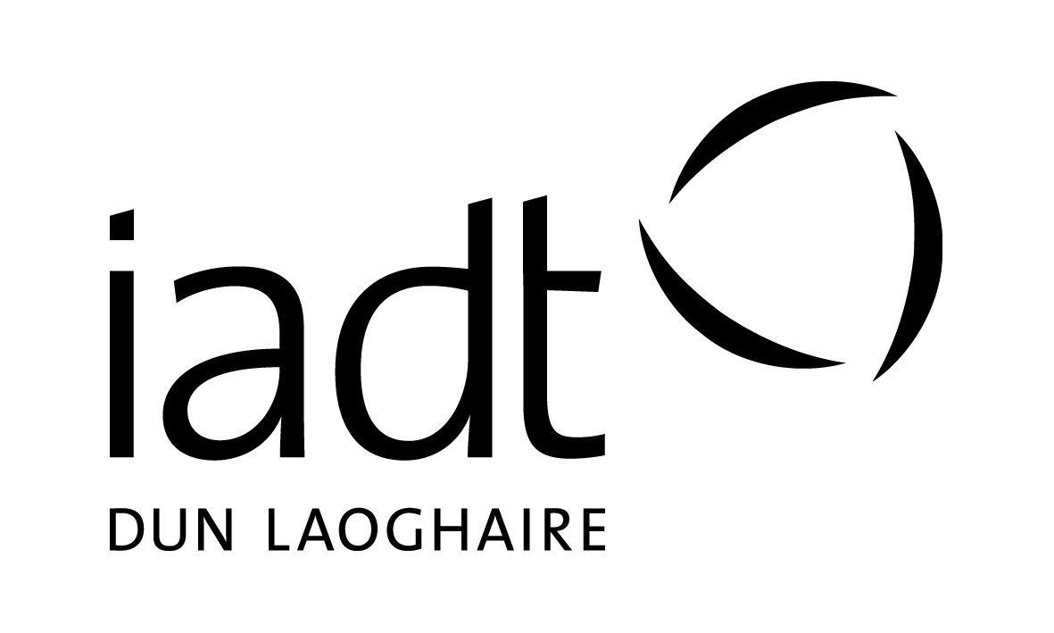
Office use
Application Form

Please complete all sections of this form in BLOCK CAPITALS using BLACK ink.
If you are applying for more than one programme please complete a separate form for each programme.

Completed forms must be returned to the admissions office.

Section 1: Personal Details

Surname: _________________ First Name(s):_________________ Date of Birth: ____________________

Address:_________________________________________________ PPS Number: ____________________

__________________________________________________________ Gender (circle): M F

__________________________________________________________ Country of Birth: ________________

Email: ____________________________________________________ Nationality: _____________________

Mobile: ___________________________________________________ Phone: _________________________

Section 2: Programme Applied For

Programme Code: _________________________

Programme Title: ________________________________________________________________________

Section 3: Are you currently a registered student at IADT?

Yes If yes, state Programme Code and year (e.g. 1st, 2nd, etc.): DL_______ Year: _______
No Current Student Number: ____________________

Section 4: Education

Please indicate the level of your current course or highest educational achievement:

Level 5 (Leaving Cert / FETAC)
Level 6 (Higher Cert / FETAC)
Level 7 (Ordinary Degree)
Level 8 (Hons Degree)
Level 9 (Masters)
Level 10 (Doctorate)

Name of College/Institution: ____________________________

Course Title: _________________________________________

Year of completion / anticipated date of completion: ________

Copy of Cert / Transcript included: Yes No

Section 5: Recognition of Prior Learning (RPL)

Applications are accepted from individuals who have proven relevant experience and whose academic background is non-traditional.

If you do not meet the standard educational requirements for the course and wish to be considered as an RPL candidate please tick this box:

You will be contacted by the programme representative responsible for RPL applicants.

For further information on the RPL process please see http://www.iadt.ie/study/how-to-apply/recognition-of-prior-learning
Section 6: Language Competence

First language*: _________________________________

Second language: _______________________________
Speak Read Write
* If your 1st language is not English you must include separate evidence of English language qualifications, such as IETLS or TOEFL Certificates. Please refer to our current Prospectus.

Section 7: Health, Disability, Specific Learning Difficulty

If you consider yourself to have a disability, significant health problem and/or specific learning difficulty please tick this box:

Please attach medical documentation (where available/relevant) or additional information on a separate sheet.

Provision of the information in this section is requested to enable the Institute of Art, Design and Technology to accommodate, where reasonable, your needs. All information provided will be treated with sensitivity and in as confidential a manner as possible.

Section 8: Reference

You must provide one reference. This should be written and can be emailed to admissions@iadt.ie or posted to: Admissions Office, IADT, Kill Avenue, Dun Laoghaire, Co Dublin.
We will assume permission to contact the named referee(s) unless you tell us otherwise.

Reference

Name of Referee: ______________________________ Telephone No. ___________________

E-mail address ________________________________________________________________________

Please Note: This application form should be completed with reference to the ‘notes’ attachment.

Section 9: Declaration

Where did you first hear about this course: ______________________________________

I certify that the information provided in this application is accurate and correct.

Signature of the Applicant: _____________________________ Date: _______________________

Note: The Institute may use information provided by the applicant to create an initial student record and compile statistical information for use by the Institute or appropriate external bodies. No statistical data which can identify individuals will be published.

Completed Application Forms and References should be mailed to:

Admissions Office (Accredited Part Time Course Application),
Institute of Art, Design and Technology
Kill Avenue, Dun Laoghaire,
Co. Dublin.

No later than 4 p.m. Wednesday the 23rd of August 2017

Please complete the this application form if you are applying for
any of the programmes listed below.

Code | Programme Title
DL101S | Certificate in Cyberpsychology
DL103S | Certificate in Data Visualisation
DL105S | Certificate in Sport Psychology
DL106S | Certificate in Critical Research (Foundation, Futures & Skills)
DL122S | Certificate in Fundamentals in UX Design
DL123S | Certificate in Design Thinking

FINAL REMINDER CHECKLIST

Before forwarding your application to the Institute, please ensure that you have included the following:

1. Copy of Transcripts of Results (where applicable). Section 4 of application form.
2. CV
3. Proof of identity – passport / drivers licence (original should not be forwarded).
4. Copy of Certificate of English Language Competence (where applicable).
5. Reference – one written reference to be attached to this form
6. If you are applying for admission to more than one programme please complete separate application forms for each programme.
7. Email address: Is your email address easy to read? - Please ensure that it is clear and legible.

P l ease n o t e that all programmes are subject to a minimum number of approved applicants to proceed.

You should forward this completed application form to:

Admissions Office (Accredited Part Time Course Application), Institute of Art, Design and Technology
Kill Avenue, Dun Laoghaire, Co. Dublin.

Or by email to: admissions@iadt.ie

Closing date for receipt of completed application forms is:
4.00 pm, 23rd August 2017
You are advised to keep a copy of this application for your own records.

INCOMPLETE APPLICATION FORMS WILL NOT BE PROCESSED

The Institute reserves the right to cancel, suspend or modify its programmes at any time. The
Institute reserves the right to amend the list of elective subjects being offered on any programme.

