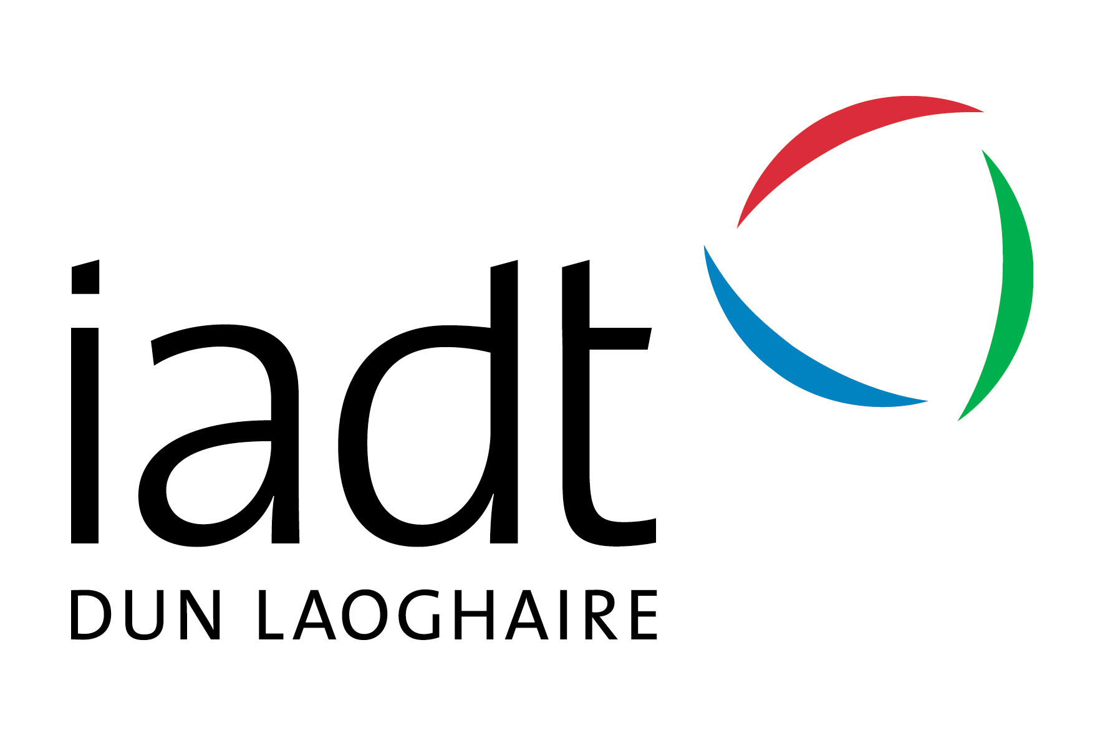 Job Descriptor

FYM Student Leaders

Urgently Required:

Student Leaders/Facilitators for IADT First Year Matters (FYM) Extended Orientation Programme: ‘First Four Weeks’

Applications due: ( via Google form https://goo.gl/forms/K9u5Sy59Mf4YPtQx2 by Sunday, April 15th at end of day (11.59 pm).
Applicants should be available for interview (in person or via Skype): Tuesday and Wednesday evenings, April 24th and 25th.
IADT is continuing the enhanced orientation programme for our incoming first year students as part of the First Year Matters (FYM) programme. We are looking for a number of individuals to liaise with the incoming first years over a number of weeks in September in a part-time capacity.
Reporting to: | Denise McMarrow, Sinead McEntee and Various Stakeholders (Student Services, Academic Services, Student Union, First Year Task-Force, First Year Tutors)

Responsibilities  General | FYM Student Leaders will be part of the creative team and will have a number of responsibilities over the programme, including:  - Organising and implementing a number of events over the First Four Weeks with the Students’ Union and FYM team.  - Welcoming and directing incoming students during registration and induction.  - Supporting SU, Management, Lecturers, Staff and Student Services during the extended orientation programme.  - Informing incoming first year students and other direct entry students about the events over the week(s).  - Directing students to the proper services available on campus to help them sort out issues they may be encountering regarding transition into third level education.  - Creating a ‘buzz’ and positive engagement ‘vibe’ across the Institution amongst students and staff by actively engaging in the events and encouraging others to participate.  Specific positions available:  General FYM Student Leader(s)  FYM Communications Officer (responsible for Marketing and all Communications primarily on Social Media (Facebook, Twitter, etc.)  FYM Scheduling and Administration Officer
Ideal Candidate Attributes | - FYM Student Leaders must be currently registered as full time students in IADT.  (i.e. have been fully registered in 2017/2018 and be eligible to go into 2018/2019)  - Have evidence-based interest as well as experience in the following:  - The Institute and in our diverse student body.  - Be familiar with the IADT Learners Charter, and other student policies (available on http://www.iadt.ie/about/policies-procedures/student-policies).  - Be hardworking and willing to ‘muck in’ to do anything from filling ‘goodie bags’ to actively attending events and cleaning up.  - Strong team member and work well in a close-knit group.  - Be outgoing and friendly with a real interest in other people.  - Be organized and have the ability to get the job done in terms of planning and implementing successful events for large groups of people.  - Be willing to speak in front of people to encourage and inspire confidence and feelings of well-being in others.  - Remember what it was like to be a first year and be interested in supporting and leading others in a team.  In addition, ideal candidates will be able to:  - Demonstrate strong people skills in interview and have evidence of previous experience similar to what is expected from the FYM leaders.  - Demonstrate attributes and prior skills as needed for the specific role(s) sought (Leader, Communications and/or Administrative Officer).  - Be willing to be ‘an Ambassador’ for the Institute and an example to First Year Students.
How Many Hours? | The positions are Monday to Friday and hours each day will vary from week to week depending on the events schedule:  You will be expected to participate in 1-2 training day(s) TBC during the week of May 21st and the week of August 26th (6-8 hours in total).  30 hours during week 1 - Induction week in September,  20 hours during the subsequent weeks (Week 2-4 in September)  This is a part time position and will NOT interfere with your own classes or weekends (Saturdays and Sundays). Hours of work will be scheduled from 8.30 am to 10.00 pm during the First Four Weeks during the different morning, lunchtime and evening first year student events. The programme finishes on Friday, the 28th of September.
If Successful, What Will I Get Paid? | Successful candidates will receive payment of €500.00 before tax and other state deductions, as applicable.
How Do I Apply? | Application Process  Please fill out the application form online by end of day, April 15th.
Questions? | Please email sinead.mcentee@iadt.ie if you have further questions.

Don’t Delay – Apply today

